At the start of each month, we get access to bulk data files from MNCIS, the Minnesota court system's case tracking system. They send MaryJo an email each month with updated passwords to access the three files via FTP.

Contact people at the courts:

Kyle Christopherson, Communications Specialist  
651-297-4029; Fax 651-268-1876  
[kyle.christopherson@courts.state.mn.us](mailto:kyle.christopherson@courts.state.mn.us)

Beau Berentson  
Director of Communications and Public Affairs  
Office: (651) 296-6043  
Cell: (651) 303-4933  
[beau.berentson@courts.state.mn.us](mailto:beau.berentson@courts.state.mn.us)

The files are: Criminal/Traffic cases, Evictions; the one called “Civil” is just monetary judgements; after we got this started, they added another file with all civil judgments (not just the monetary ones) and that is now in there called “NewCivil”

Note: this does not cover all cases, particularly civil cases. In addition, it only goes back to about 2009, when MNCIS system was created. We have data files with older cases, civil and criminal, stored in the crime database on amazon1 server. The criminal is called “MNCIS_old_crim” and the civil is made up of two tables – Civil_old_Cases and Civil_old_Parties

To download the files:  
The court provided a how-to document (that is stored in this repo), however I discovered some little quirks in using FileZilla that the directions don’t cover.

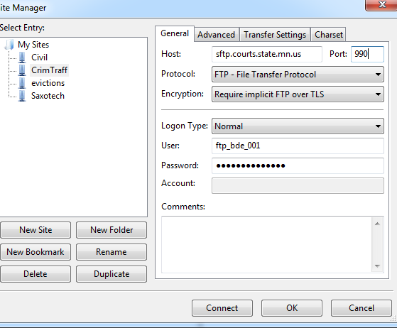In the Site Manager, on the general tab, fill in the host, port, user and password fields.

The only thing that changes from month-to-month is the password.

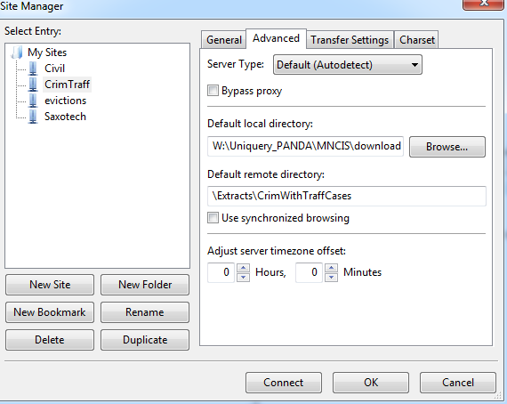Under the “advanced” tab is where you put the remote directory address:

Then push the Connect tab and it should show you the files (on the right side) and you can drag them across to the local directory on the left side.

Criminal:  
USER: ftp_bde_001  
REMOTE DIRECTORY: \Extracts\CrimWithTraffCases

All Civil:  
USER: ftp_bde_005  
remote DIRECTORY: \Extracts\CivilAllExtract

Evictions:  
USER: ftp_bde_004  
REMOTE DIRECTORY: \Extracts\Evictions-UnlawfulDetainer

IMPORTANT NOTE: When it’s finished, copy the “log” that shows up at the top of Filezilla that tracked the importing process and save that in the directory where the files were downloaded. We need to keep a history of when we update these files as part of the indemnity agreement we had to sign with the courts in order to have access to these files. They want proof that we deleted the old files and imported the new files each month.

In the crime database on amazon1 server there is a saved query called **“mncis_importscript”** that you can run after the files have downloaded. The script deletes the old data and imports the new data for all three tables. It also enters records into a table called “MNCIS_log” that I’m using to track the deletion and importing, and then it also updates the “inventory” table to reflect that the data has been updated. (a backup copy of this script is stored in this repo)